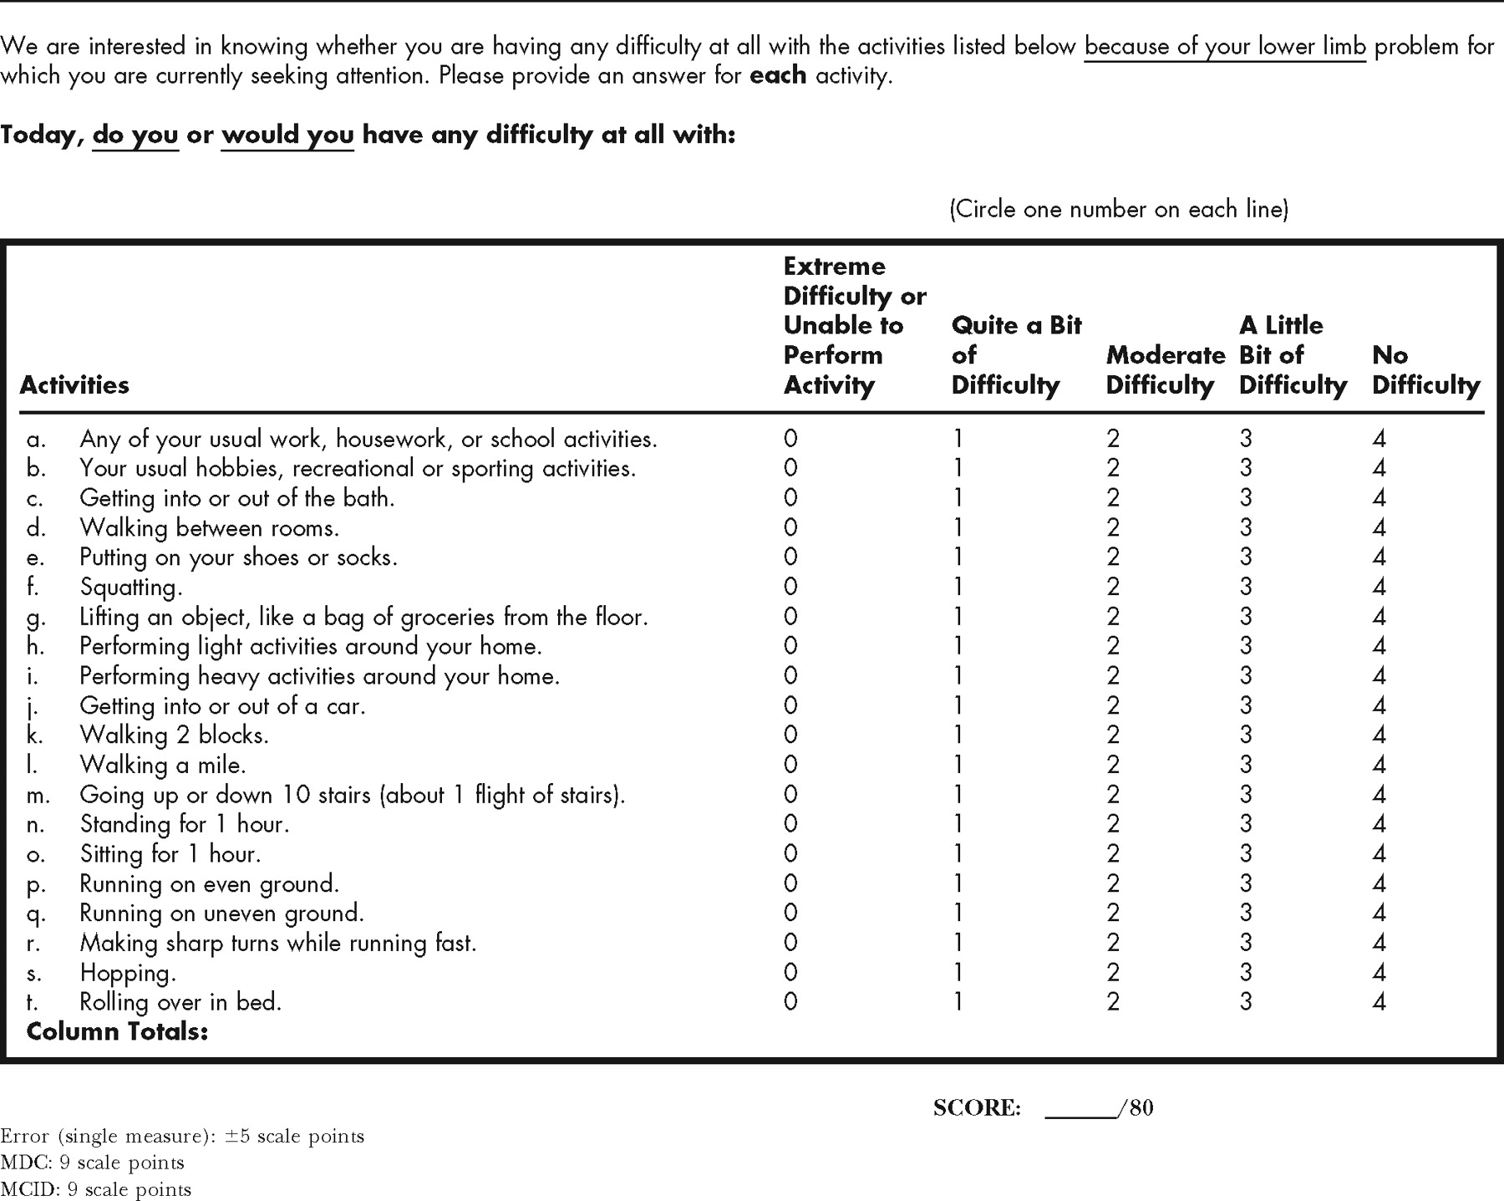
THE LOWER EXTREMITY FUNCTIONAL SCALE

